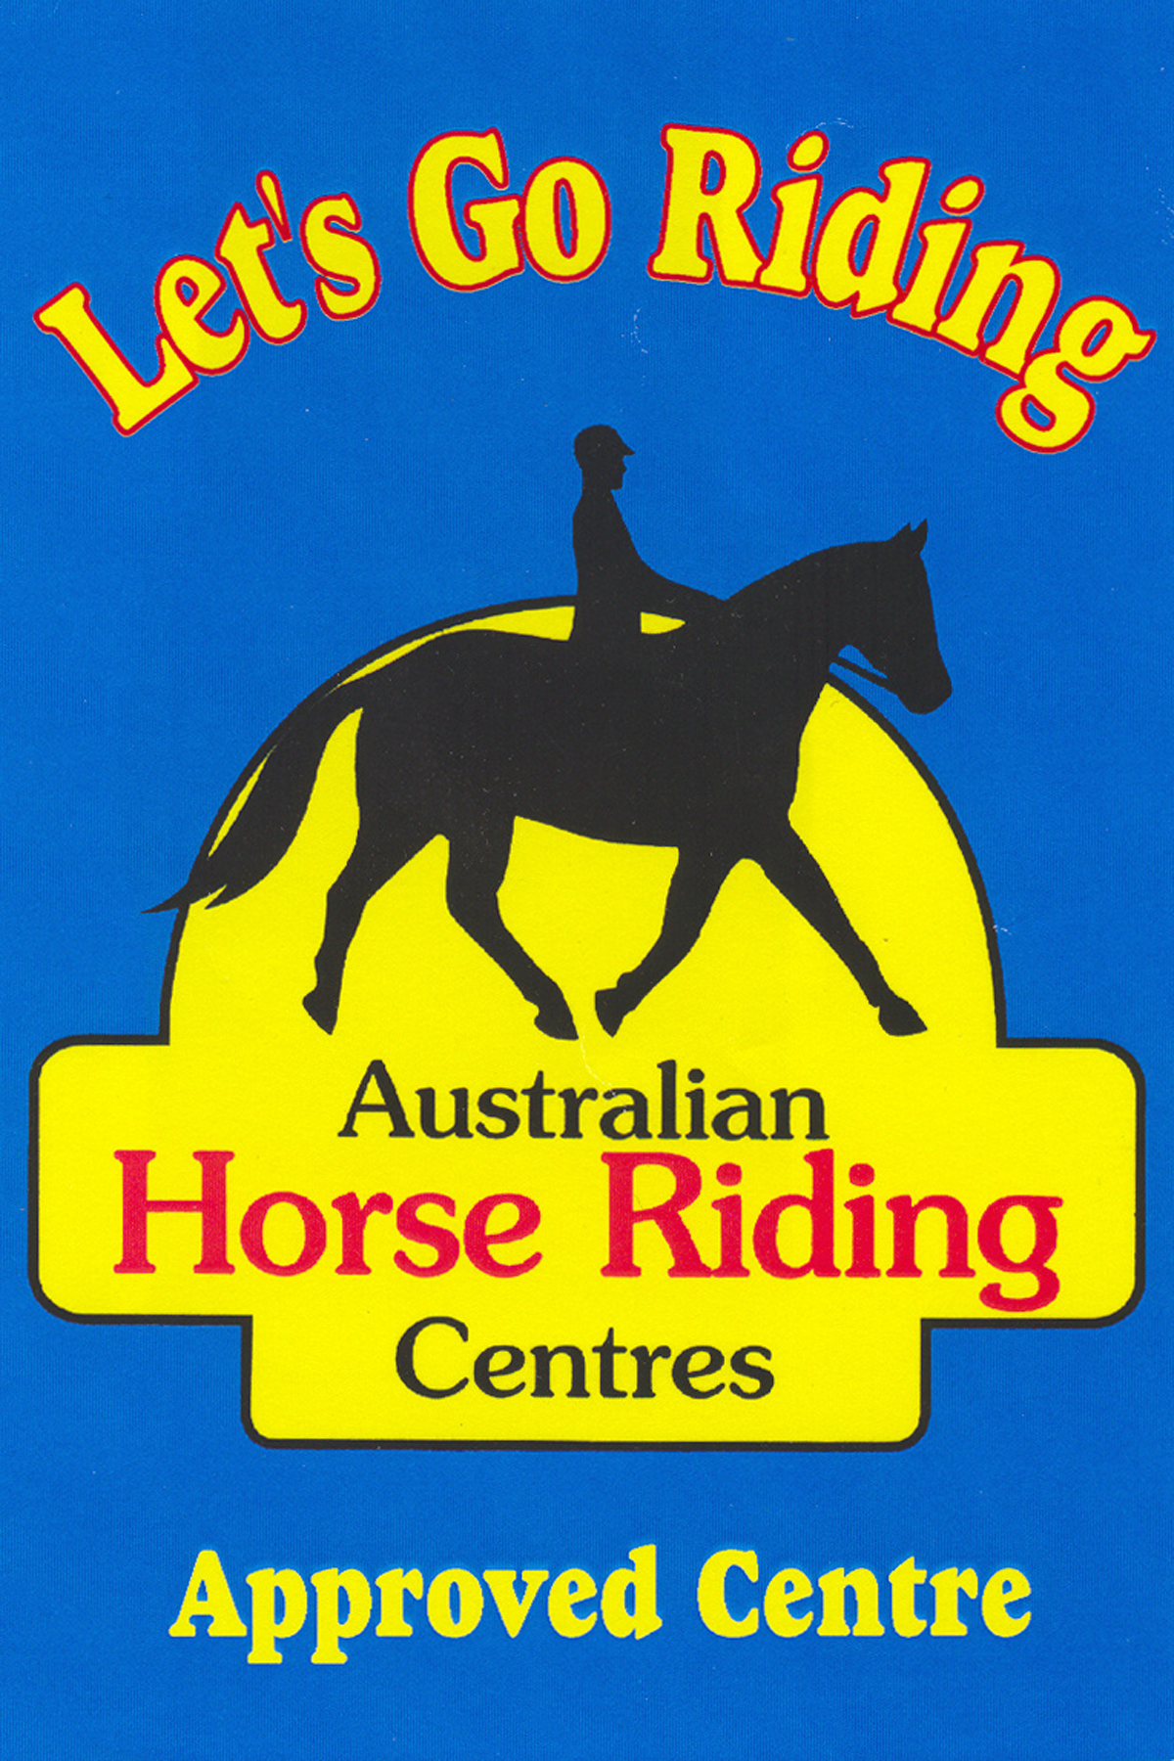
AHRC NSW LEVEL 1 RECREATIONAL COACH

TRAINEE REGISTRATION
&
STUDY GUIDE & MANUAL ORDER FORM

NAME_____________________________________GENDER Male / Female

ADDRESS____________________________________________________
__________________________________POST CODE________________

PHONE
HM________________Work________________Mobile________________

EMAIL_______________________________________________________

NAME OF AHRC TRAINING CENTRE____________________________

REGISTRATION FOR: AHRC RECREATIONAL COACH (Certificate 2 only) Please include $20 registration fee

AHRC Recreational Coaching Level 1:
Certificate 1 – Horse Management $50.00
Certificate 2 – Teaching a Beginner $50.00 (must include additional $20 registration and copy of current First Aid Certificate)
Certificate 3 - Practical Riding & Coaching Skills $50.00
(Includes GST and postage)

DATE______________SIGNATURE_______________________________

RETURN THIS FORM AND PAYMENT TO (cheques and money orders made out to Australian Horse Riding Centres)

AHRC NSW
PO Box 285
Engadine NSW 2233

